Ridlington Playing Field Questionnaire

Age range in your house (tick all that apply)
Toddler 4 – 10 11 – 16 Adult

What sports and activities do you like to participate in?

Would you be interested in playing any of the following (tick all that apply):
Cricket
Petanque
Football
Other (please describe)………………………………………………………………………………………..

What sort of equipment would you use?
(Be honest with yourself, will you use it after the novelty has worn off!)
Prioritise your top 3 (1=favourite). These are just examples you are welcome to suggest others.

Swinging Sliding
Playhouse Climbing
Zip wire Rocking
Rotating Balancing
Fitness
Other (please state)…………………………………………………………………………….

What events / fund-raising ideas would you be interested in supporting? (Tick all that apply. We appreciate some may not be possible to do at the moment.)
100 Club Sports Day
Safari lunch or supper Pudding & Prosecco
Cheese & Port evening Amazon Smile
Open Gardens Quiz
Playing cards Bingo
Cuppa & Cake Talent show
Dog show
Sponsored (suggestions)………………………………………………………………………………………
Other (please suggest)…………………………………………………………………………………………..

Which days / times are better for you to attend an event?

How else could you help? E.g. hour’s labour, social media help, donate raffle prize, printing, creative skills, possible links to potential funders or businesses etc.

Other ideas and comments:

Names (s)
Address
Telephone
Email
Please return the questionnaire to Suzanne Baines: suzannebaines@outlook.com 01572 823542 / 07465 409477
If you prefer to print the questionnaire you are welcome to drop off to:
- Suzanne Baines at The Manor, 17 Main Street
Or
- Ruth Lees, at The Old Post Office, 5 Top Road.

Here are a few equipment examples to give you a very approximate idea of costs:
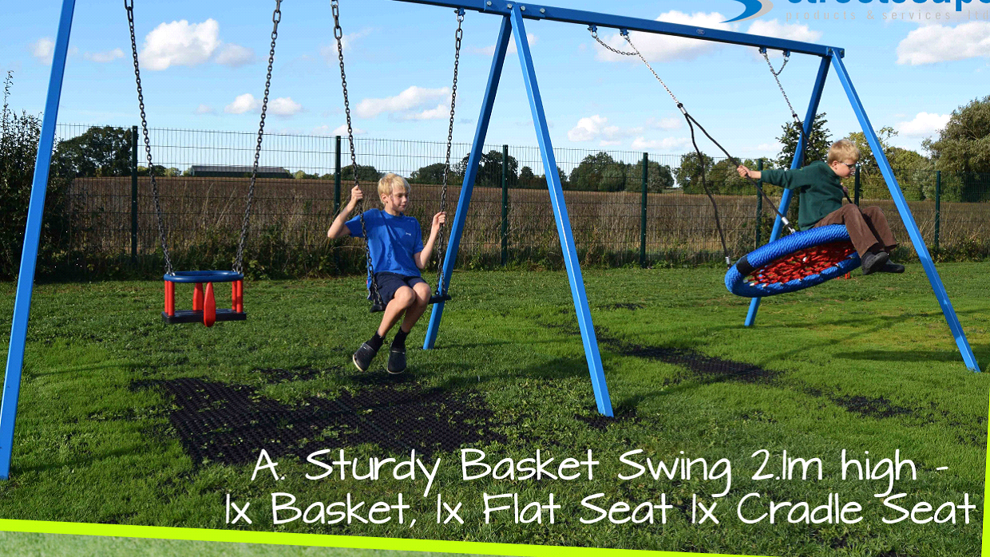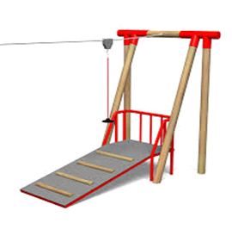
£4,000 (3 different swings) Zip Wire £5,500 - £6,000

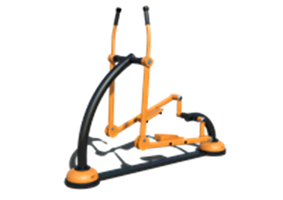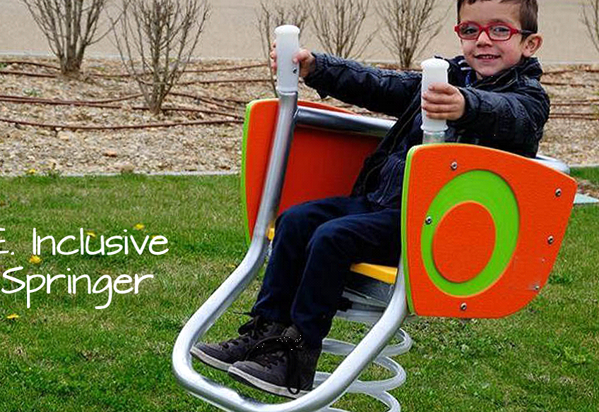
£2,000 - £4,000 £2,000 £800 - £1,000

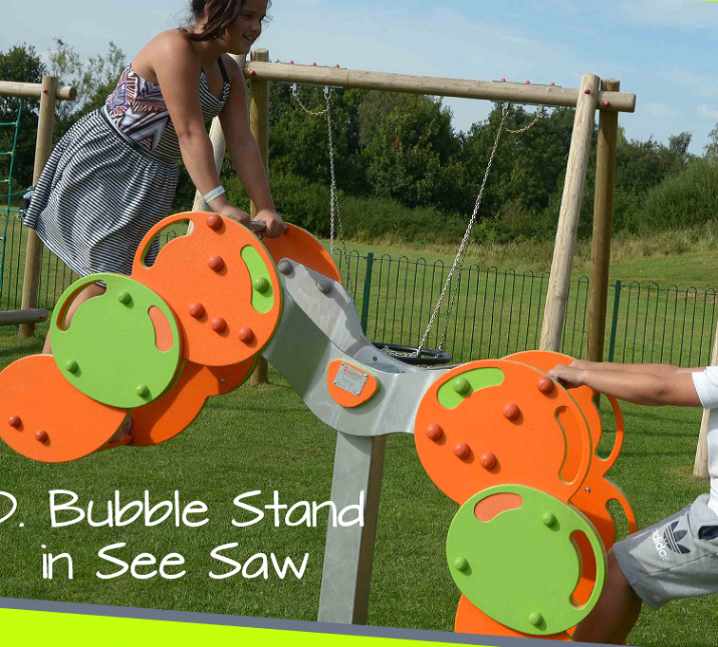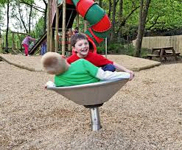
£1,400 £1,300

