INTRODUCTION TO BREATHWORK
PRESTON VILLAGE HALL, 11th MAY, 6.30 – 7.30PM
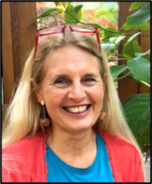
Consciously changing the way you breathe can significantly improve your health. In particular it helps to:
- REDUCE ANXIETY & STRESS
- REDUCE BLOOD PRESSURE
- IMPROVE SLEEP
- IMPROVE DIGESTION
- BALANCE MOOD / ENERGY
- INCREASE MENTAL FOCUS
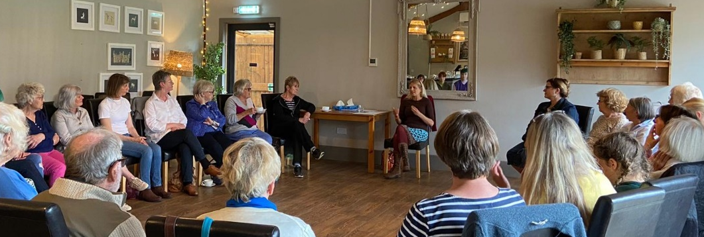
This informative and practical workshop will give you the know-how and tools to improve your own breathing. By understanding the science, you will learn what effects the way you breathe has on your body and why conscious breathing is so important for your health.
Breathwork is accessible for everyone, so to reach as many as possible this event is by donation; just pay at the end an amount you feel you can afford, and which reflects the value you have got from the workshop.
If you’d like to attend, please contact me to book your place.
Polly Rubinstein
E: polly.rubinstein@zen.co.uk
T: 07803 184113

